ONEWAY CRT BY Age
/STATISTICS DESCRIPTIVES HOMOGENEITY WELCH
/PLOT MEANS
/MISSING ANALYSIS.

Oneway

Notes
Output Created |  | 05-May-2019 23:19:38
Comments
Input | Active Dataset | DataSet0
Input | Filter | <none>
Input | Weight | <none>
Input | Split File | <none>
Input | N of Rows in Working Data File | 30
Missing Value Handling | Definition of Missing | User-defined missing values are treated as missing.
Missing Value Handling | Cases Used | Statistics for each analysis are based on cases with no missing data for any variable in the analysis.
Syntax |  | ONEWAY CRT BY Age  /STATISTICS DESCRIPTIVES HOMOGENEITY WELCH  /PLOT MEANS  /MISSING ANALYSIS.
Resources | Processor Time | 00 00:00:00.172
Resources | Elapsed Time | 00 00:00:00.179

[DataSet0]

Descriptives
 | N | Mean | Std. Deviation | Std. Error | 95% Confidence Interval for Mean
 |  |  |  |  | Lower Bound | Upper Bound
18 | 1 | 8.2000 | . | . | . | .
19 | 2 | 11.7000 | .42426 | .30000 | 7.8881 | 15.5119
20 | 2 | 12.9000 | .98995 | .70000 | 4.0057 | 21.7943
21 | 2 | 9.0000 | 5.93970 | 4.20000 | -44.3661 | 62.3661
22 | 9 | 9.3000 | 3.11609 | 1.03870 | 6.9048 | 11.6952
23 | 1 | 9.4000 | . | . | . | .
24 | 1 | 5.0000 | . | . | . | .
25 | 1 | 4.4000 | . | . | . | .
28 | 2 | 6.0000 | .56569 | .40000 | .9175 | 11.0825
30 | 1 | 6.8000 | . | . | . | .
41 | 1 | 9.2000 | . | . | . | .
43 | 1 | 8.8000 | . | . | . | .
48 | 3 | 9.0000 | 5.03190 | 2.90517 | -3.4999 | 21.4999
52 | 1 | 9.6000 | . | . | . | .
56 | 1 | 4.0000 | . | . | . | .
58 | 1 | 3.8000 | . | . | . | .
Total | 30 | 8.6367 | 3.32291 | .60668 | 7.3959 | 9.8775

Descriptives
 | Minimum | Maximum
18 | 8.20 | 8.20
19 | 11.40 | 12.00
20 | 12.20 | 13.60
21 | 4.80 | 13.20
22 | 4.50 | 14.00
23 | 9.40 | 9.40
24 | 5.00 | 5.00
25 | 4.40 | 4.40
28 | 5.60 | 6.40
30 | 6.80 | 6.80
41 | 9.20 | 9.20
43 | 8.80 | 8.80
48 | 3.20 | 12.20
52 | 9.60 | 9.60
56 | 4.00 | 4.00
58 | 3.80 | 3.80
Total | 3.20 | 14.00

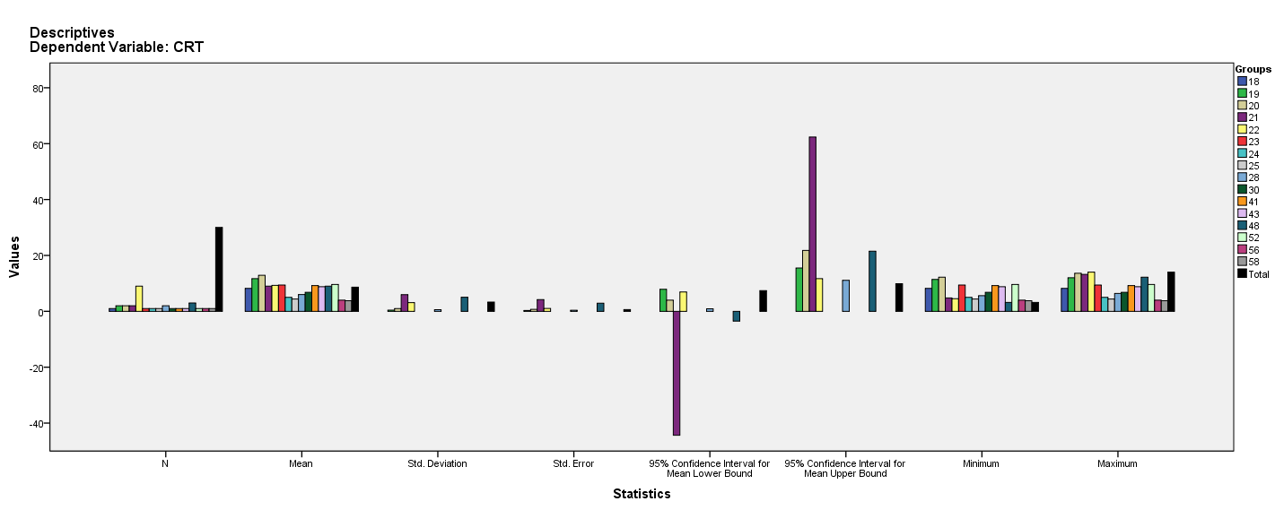

Test of Homogeneity of Variances
CRT
Levene Statistic | df1 | df2 | Sig.
3.557ª | 5 | 14 | .028
a. Groups with only one case are ignored in computing the test of homogeneity of variance for CRT.

ANOVA
CRT
 | Sum of Squares | df | Mean Square | F | Sig.
Between Groups | 155.130 | 15 | 10.342 | .877 | .599
Within Groups | 165.080 | 14 | 11.791
Total | 320.210 | 29

Robust Tests of Equality of Means^{b}
CRT
 | Statisticª | df1 | df2 | Sig.
Welch | . | . | . | .
a. Asymptotically F distributed.
b. Robust tests of equality of means cannot be performed for CRT because at least one group has the sum of case weights less than or equal to 1.

Means Plots

